DAY 1 – 09.04.2024

LEETCODE PROLEM SUBMISSION

https://leetcode.com/problems/longest-palindromic-substring/submissions/1227499207/  
  
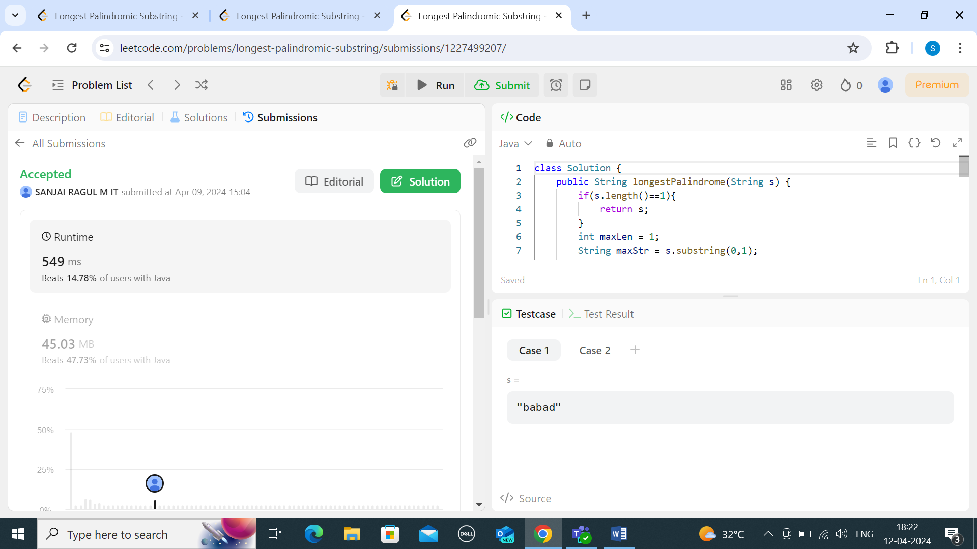

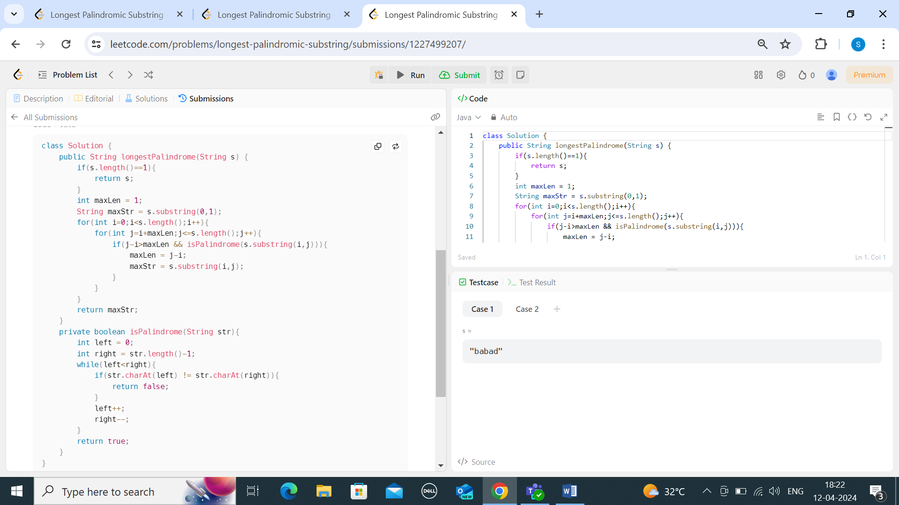

2) TWO SUM

